Software Requirements Specification

Table of Contents

[**1. INTRODUCTION    2**](https://docs.google.com/document/d/1ER7tG-ASfA7frToITjUnGGrPIF_eIBkYp6zvq277aMk/edit#heading=h.ntitqw5r345y)

[1.1 PURPOSE    2](https://docs.google.com/document/d/1ER7tG-ASfA7frToITjUnGGrPIF_eIBkYp6zvq277aMk/edit#heading=h.1fob9te)

[1.2 DOCUMENT CONVENTIONS    2](https://docs.google.com/document/d/1ER7tG-ASfA7frToITjUnGGrPIF_eIBkYp6zvq277aMk/edit#heading=h.rl5k5o7snsft)

[1.3 INTENDED AUDIENCE AND READING SUGGESTIONS    2](https://docs.google.com/document/d/1ER7tG-ASfA7frToITjUnGGrPIF_eIBkYp6zvq277aMk/edit#heading=h.1ky9spkpz4ka)

[1.4 PROJECT SCOPE    2](https://docs.google.com/document/d/1ER7tG-ASfA7frToITjUnGGrPIF_eIBkYp6zvq277aMk/edit#heading=h.2et92p0)

[1.5 REFERENCES    2](https://docs.google.com/document/d/1ER7tG-ASfA7frToITjUnGGrPIF_eIBkYp6zvq277aMk/edit#heading=h.gt7ubks4byz7)

[**2. OVERALL DESCRIPTION    2**](https://docs.google.com/document/d/1ER7tG-ASfA7frToITjUnGGrPIF_eIBkYp6zvq277aMk/edit#heading=h.tyjcwt)

[2.1 PRODUCT PERSPECTIVE    2](https://docs.google.com/document/d/1ER7tG-ASfA7frToITjUnGGrPIF_eIBkYp6zvq277aMk/edit#heading=h.3dy6vkm)

[2.2 USER CLASS and CHARACTERISTICS    3](https://docs.google.com/document/d/1ER7tG-ASfA7frToITjUnGGrPIF_eIBkYp6zvq277aMk/edit#heading=h.1t3h5sf)

[**3. SYSTEM FEATURES    3**](https://docs.google.com/document/d/1ER7tG-ASfA7frToITjUnGGrPIF_eIBkYp6zvq277aMk/edit#heading=h.4d34og8)

[3.1 DESCRIPTION and PRIORITY    3](https://docs.google.com/document/d/1ER7tG-ASfA7frToITjUnGGrPIF_eIBkYp6zvq277aMk/edit#heading=h.2s8eyo1)

[3.2 STIMULUS/RESPONSE SEQUENCES    3](https://docs.google.com/document/d/1ER7tG-ASfA7frToITjUnGGrPIF_eIBkYp6zvq277aMk/edit#heading=h.17dp8vu)

[3.3 FUNCTIONAL REQUIREMENTS    3](https://docs.google.com/document/d/1ER7tG-ASfA7frToITjUnGGrPIF_eIBkYp6zvq277aMk/edit#heading=h.3rdcrjn)

[**4. EXTERNAL INTERFACE REQUIREMENTS    4**](https://docs.google.com/document/d/1ER7tG-ASfA7frToITjUnGGrPIF_eIBkYp6zvq277aMk/edit#heading=h.26in1rg)

[4.1 HARDWARE INTERFACES    4](https://docs.google.com/document/d/1ER7tG-ASfA7frToITjUnGGrPIF_eIBkYp6zvq277aMk/edit#heading=h.lnxbz9)

[4.2 SOFTWARE INTERFACES    4](https://docs.google.com/document/d/1ER7tG-ASfA7frToITjUnGGrPIF_eIBkYp6zvq277aMk/edit#heading=h.35nkun2)

[**5. NONFUNCTIONAL REQUIREMENTS    5**](https://docs.google.com/document/d/1ER7tG-ASfA7frToITjUnGGrPIF_eIBkYp6zvq277aMk/edit#heading=h.1ksv4uv)

[5.1 PERFORMANCE REQUIREMENTS    5](https://docs.google.com/document/d/1ER7tG-ASfA7frToITjUnGGrPIF_eIBkYp6zvq277aMk/edit#heading=h.44sinio)

[5.2 SAFETY REQUIREMENTS    5](https://docs.google.com/document/d/1ER7tG-ASfA7frToITjUnGGrPIF_eIBkYp6zvq277aMk/edit#heading=h.2jxsxqh)

[5.3 SECURITY REQUIREMENTS    6](https://docs.google.com/document/d/1ER7tG-ASfA7frToITjUnGGrPIF_eIBkYp6zvq277aMk/edit#heading=h.z337ya)

[5.4 SOFTWARE QUALITY ATTRIBUTES    6](https://docs.google.com/document/d/1ER7tG-ASfA7frToITjUnGGrPIF_eIBkYp6zvq277aMk/edit#heading=h.3j2qqm3)

1. INTRODUCTION

1.1 PURPOSE

The purpose of this document is to build an online system meant to support the automatic management of scientific conferences.

1.2 DOCUMENT CONVENTIONS

CMS = Conference Management System

PC = PROGRAM COMMITTEE

1.3 INTENDED AUDIENCE AND READING SUGGESTIONS

This project is a prototype for a conference management system and it is restricted within the faculty premises. It will be implemented under the guidance of faculty professors. The project is meant to be useful both for conference organizing teams and participants (authors).

1.4 PROJECT SCOPE

The purpose of the online conference management system is to ease conference management and to create a convenient and intuitive application both for the members of the Program Committee (organizers) and the participants (session chairs, speakers or listeners). The system will be based on a relational database that manages information concerning the authors submitting proposals, the members of the Program Committee, the abstracts and full papers proposed, reviewers and results of the paper evaluation.

1.5 REFERENCES

https://classroom.google.com/w/NjIwNjUzNzg3Nzla/t/all

Object-Oriented Software Engineering Using UML, Patterns, and Java, by Bernd Bruegge & Allen H. Dutoit

2. OVERALL DESCRIPTION

2.1 PRODUCT PERSPECTIVE

A conference management system stores the following information:

PC Members:  
It includes the name, affiliation, email address, their personal web-page, their username for the CMS and the password for accessing the information about the conference.

Authors:  
User account: name, affiliation, email address.

Abstract:  
Abstract, name of the proposal, keywords, topics, list of authors, possibly the full paper.

2.2 USER CLASS and CHARACTERISTICS

The system will support two types of user privileges, Program Committee member and Participant.

Participants should be able to do the following:

* create a new user account
* submit a proposal until a given deadline
* submit a paper until a given deadline
* participate as a speaker or listener

Members of the Program Committee should be able to do the following:

* update the information about the conference
* update deadlines
* bid proposals
* review proposals
* chair sessions

3. SYSTEM FEATURES

3.1 DESCRIPTION and PRIORITY

The conference management system maintains information on conferences, on proposals, authors, reviewers, members of P.C, accounts of other members. This project has a somewhat of a priority because it is useful to participate at conferences that might change a lot of things that we know or do. It’s similar to a brainstorming activity, but it’s something more advanced and well organized that could change our world in some degree.

3.2 STIMULUS/RESPONSE SEQUENCES

* Organize a conference.
* Authors propose papers with only an abstract.
* Pseudo-review done by P.C members of the papers submitted.
* Review done by the reviewers for each paper accepted by P.C members.
* Author can change the contents of his paper if accepted.
* Author with accepted papers can participate at the conference as a speaker.
* The conference can have multiple sections and can participate multiple people.
* End of the conference.

3.3 FUNCTIONAL REQUIREMENTS

Other system features include:

*DISTRIBUTED DATABASE:*

Distributed database implies that a single application should be able to operate transparently on data that is spread across a variety of different databases and connected by a communication network as shown in below figure.

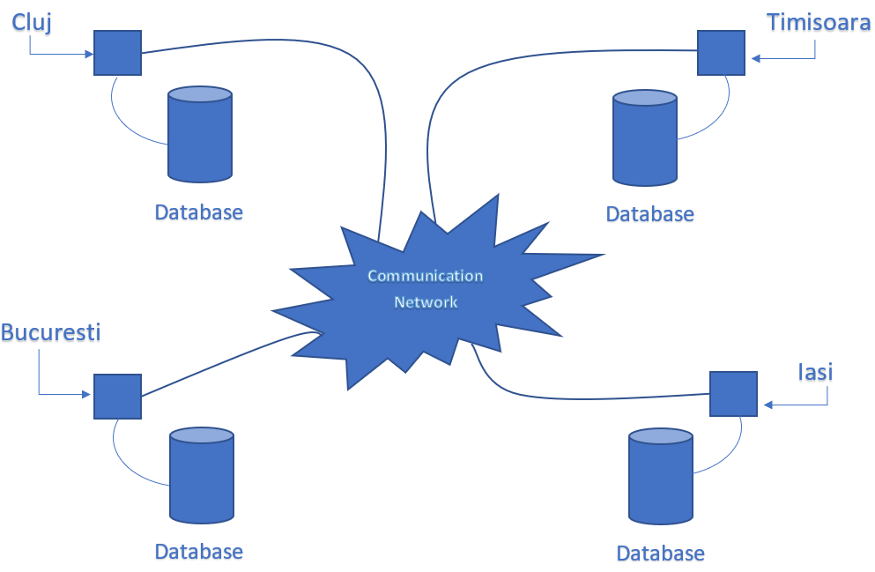

*CLIENT/SERVER SYSTEM*

The term client/server refers primarily to an architecture or logical division of responsibilities, the client is the application (also known as the front-end), and the server is the DBMS (also known as the back-end).

A client/server system is a distributed system in which,

Some sites are client sites and others are server sites.

All the data resides at the server sites.

All applications execute at the client sites.

4. EXTERNAL INTERFACE REQUIREMENTS

4.1 HARDWARE INTERFACES

Windows.

4.2 SOFTWARE INTERFACES

Following are the software used for the conference management online application.

|  |  |
| --- | --- |
| Software used | Description |
| Operating system | We have chosen Windows operating system for its best support and user-friendliness. |
| Database | To save the proposals records, users records we have chosen SQL database. |

5. NONFUNCTIONAL REQUIREMENTS

5.1 PERFORMANCE REQUIREMENTS

The steps involved to perform the implementation of the conference management system database are as listed below.

*A) ENTITY RELATIONSHIP DIAGRAM*

The Entity Relationship Diagram constitutes a technique for representing the logical structure of a database in a pictorial manner. This analysis is then used to organize data as a relation, normalizing relation and finally obtaining a relation database.

ENTITIES: Which specify distinct real-world items in an application.

PROPERTIES/ATTRIBUTES: Which specify properties of an entity and relationships.

RELATIONSHIPS: Which connect entities and represent meaningful dependencies between them.

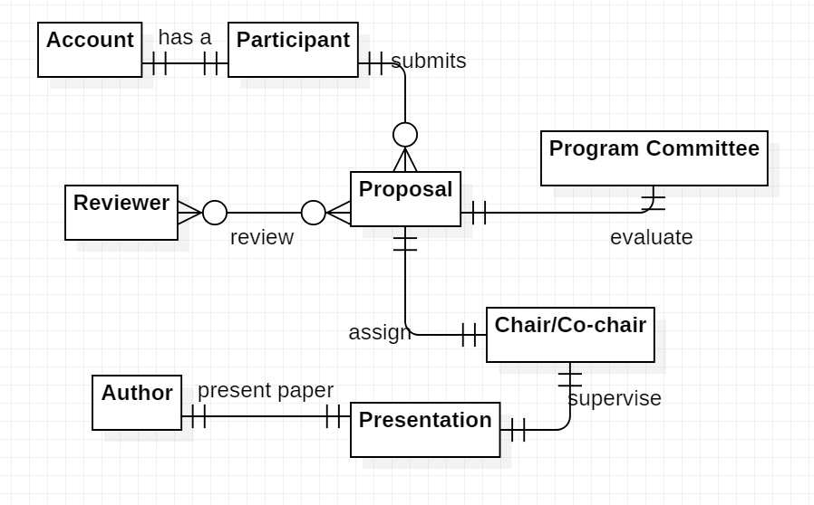

the diagram shows the entity-relationship diagram of the conference management system database

*B) NORMALIZATION:*

The basic objective of normalization is to reduce redundancy which means that information is to be stored only once. Storing information several times leads to wastage of storage space and increase in the total size of the data stored.

If a database is not properly designed it can give rise to modification anomalies. Modification anomalies arise when data is added to, changed or deleted from a database table. Similarly, in traditional databases as well as improperly designed relational databases, data redundancy can be a problem. These can be eliminated by normalizing a database.

Normalization is the process of breaking down a table into smaller tables. So that each table deals with a single theme. There are three different kinds of modifications of anomalies and formulated the first, second and third normal forms (3NF) is considered sufficient for most practical purposes. It should be considered only after a thorough analysis and complete understanding of its implications.

5.2 SAFETY REQUIREMENTS

If there is some extensive damage to a portion of the database or to a part of the application due to a catastrophic failure, such as disk crash, the recovery method restores a past copy of the affected data that is backed up in the archival storage and reconstructs a current state by reapplying or redoing the operations performed in that time frame (i.e. uploaded papers, finalized reviews, account creation) from the backed up log, up to the time of failure.

5.3 SECURITY REQUIREMENTS

In order to verify the authentication of the members of a conference, some security requirements should be defined in advance: username for the Conference Management System and the password for accessing the information about the event.

5.4 SOFTWARE QUALITY ATTRIBUTES

AVAILABILITY: The paper’s should be available for update until the specified date as a lot of updates will be submitted.

CORRECTNESS: The paper presentation should start from the correct date and should end at the correct date.

MAINTAINABILITY: The Program Committee should maintain the correctness of the section’s schedules.

USABILITY: The conference manager should satisfy a maximum number of authors and PC member’s needs.